WIN or LOSE (100 Marks)

A new fighting game has become popular. There are N number of villains with each having some strength. There are N players in the game with each having some energy. The energy is used to kill the villains. The villain can be killed only if the energy of the player is greater than the strength of the villain.

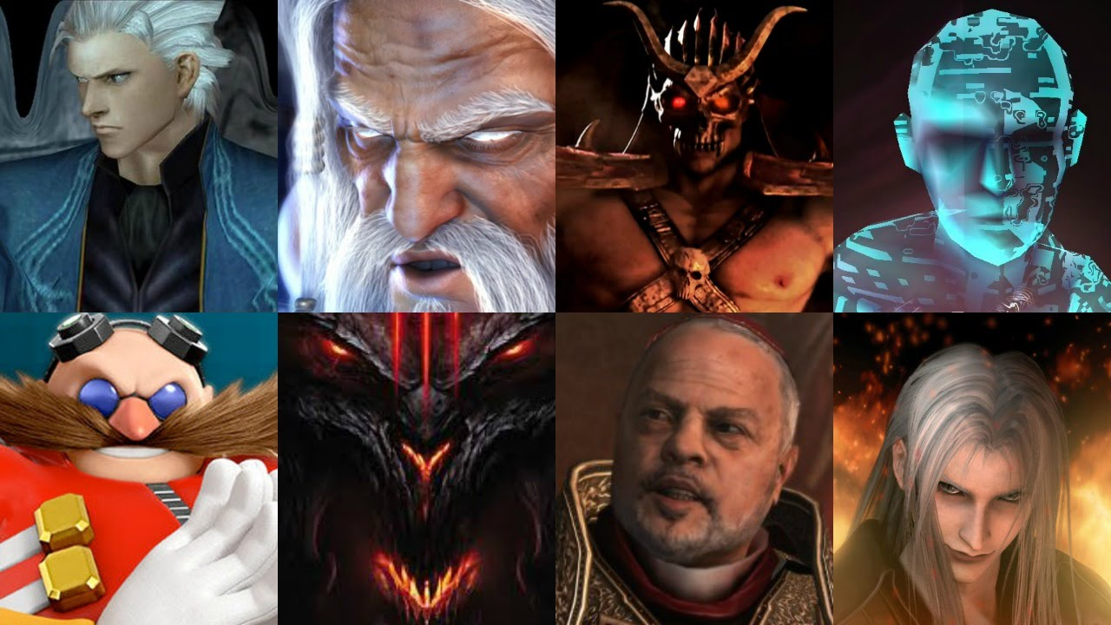

Maxi is playing the game and at a particular time wants to know if it is possible for him to win the game or not with the given set of energies and strengths of players and villains. Maxi wins the game if his players can kill all the villains with the allotted energy.

**Input Format**

The first line of input consist of number of test cases, T.

The first line of each test case consist of number of villains and player, N.

The second line of each test case consist of the N space separated strengths of Villains.

The third line of each test case consist of N space separated energy of players.

**Constraints**

1<= T <=10

1<= N <=1000

1<= strength , energy <=100000

##### 

**Output Format**

For each test case, Print **WIN** if all villains can be killed else print **LOSE** in separate lines.

**Sample TestCase 1**

Input

1  
6  
112 243 512 343 90 478   
500 789 234 400 452 150

Output

WIN

Explanation

For the given test case, If we shuffle the players and villains, we can observe that all the villains can be killed by players.

|  |  |  |
| --- | --- | --- |
| Player | Villain | RESULT |
| 500 | 478 | WIN |
| 789 | 512 | WIN |
| 234 | 112 | WIN |
| 400 | 243 | WIN |
| 452 | 343 | WIN |
| 150 | 90 | WIN |

As all the villains can be killed by the players, MAXI will WIN the game. Thus, the final output is WIN.

**Sample TestCase 2**

Input

2  
6  
10 20 50 100 500 400   
30 20 60 70 90 490   
5  
10 20 30 40 50   
40 50 60 70 80

Output

LOSE

WIN

**Time Limit(X):**

1.00 sec(s) for each input.

**Memory Limit:**

512 MB

**Source Limit:**

100 KB

**Allowed Languages:**

C, C++, C++11, C++14, C#, Java, Java 8, Kotlin, PHP, PHP 7, Python, Python 3, Perl, Ruby, Node Js, Scala, Clojure, Haskell, Lua, Erlang, Swift, VBnet, Js, Objc, Pascal, Go, F#, D, Groovy, Tcl, Ocaml, Smalltalk, Cobol, Racket, Bash, GNU Octave, Rust, Common LISP, R, Julia, Fortran, Ada, Prolog, Icon, Elixir, CoffeeScript, Brainfuck, Pypy, Lolcode, Nim, Picolisp, Pike, pypy3

<http://twitter.github.io/effectivescala/#Types%20and%20Generics-Type%20aliases>

## Neighbours and New Year Party (100 Marks)

In the XYZ society, the neighbours hate each other for their attitude. Various activities are organized in the society for Welcoming the New Year. The tickets were provided to each house with an integer written on it. Some got tickets with positive integers and some got tickets with negative integers. In the evening, people had to carry their tickets to the club house where the eligible ones will get the exciting gifts. The eligibility of winning the gift depends on the maximum sum which can be formed from the tickets numbers keeping in mind that neighbours hate each other. Since the neighbours hate each other, the two cannot be together in the list of maximum sum.

The President of the society, Mr. Singh, is a wise man and know that neighbours in society don't like each other. Also, he don't wish to become bad in front of people. So, he came up with an idea to design a program which will provide the list of integers forming maximum sum and thus all the members of the list will be given the gifts. The only problem with this idea is that he don't know programming so he is asking you to provide the correct list of integers. The people may be annoying but are smart and will fight if the list provided by you doesn't form the maximum sum.

**Note:** The integer written on ticket of individuals may or may not be unique. In case, when there are two list with equal maximum sum, the list with first greater element would be considered. For better understanding, look at the explanation of Test case 4 in Sample Test Case. The tickets with integer 0 are not considered for winning the gifts.

##### Input Format

The first line of input consist of number of test cases, T.

The first line of each test case consist of the number of houses (tickets distributed) in society, N.

The second line of each test case consist of N space separated tickets with integer written on them.

Constraints

1<= T <=10

1<= N <=10000

-1000<= Integer_on_Ticket <=1000

##### Output Format

For each test case, print the ticket numbers in a single line forming the maximum sum in the format similar to Sample Test Case.

##### Sample TestCase 1

###### Input

5  
5  
-1 7 8 -5 4   
4  
3 2 1 -1   
4  
11 12 -2 -1   
4  
4 5 4 3   
4  
5 10 4 -1

###### Output

48

13

12

44

10

###### Explanation

###### 5 10 4 -1

###### 10 5 4 -1

###### 10 10 5 4 -1

Test Case 1: Maximum sum which can be formed is 12. Element considered 8, 4. Note that Output is printed from the reverse side of the array which is TRUE for all the test cases without the space. So, the output is 48.  
Test Case 2: Maximum sum which can be formed is 4. Element considered 3, 1. Output = 13.  
Test Case 3: Maximum sum which can be formed is 12 as by taking any other element value of maximum sum decreases.  
Test Case 4: Maximum sum which can be formed is 8 by taking 3, 5 or 4, 4. But the output is 4, 4 as 3 is smaller than 4.  
Test Case 5: Maximum sum which can be formed is 10.

**Time Limit(X):**

0.70 sec(s) for each input.

**Memory Limit:**

512 MB

**Source Limit:**

100 KB

**Allowed Languages:**

C, C++, C++11, C++14, C#, Java, Java 8, Kotlin, PHP, PHP 7, Python, Python 3, Perl, Ruby, Node Js, Scala, Clojure, Haskell, Lua, Erlang, Swift, VBnet, Js, Objc, Pascal, Go, F#, D, Groovy, Tcl, Ocaml, Smalltalk, Cobol, Racket, Bash, GNU Octave, Rust, Common LISP, R, Julia, Fortran, Ada, Prolog, Icon, Elixir, CoffeeScript, Brainfuck, Pypy, Lolcode, Nim, Picolisp, Pike, pypy3

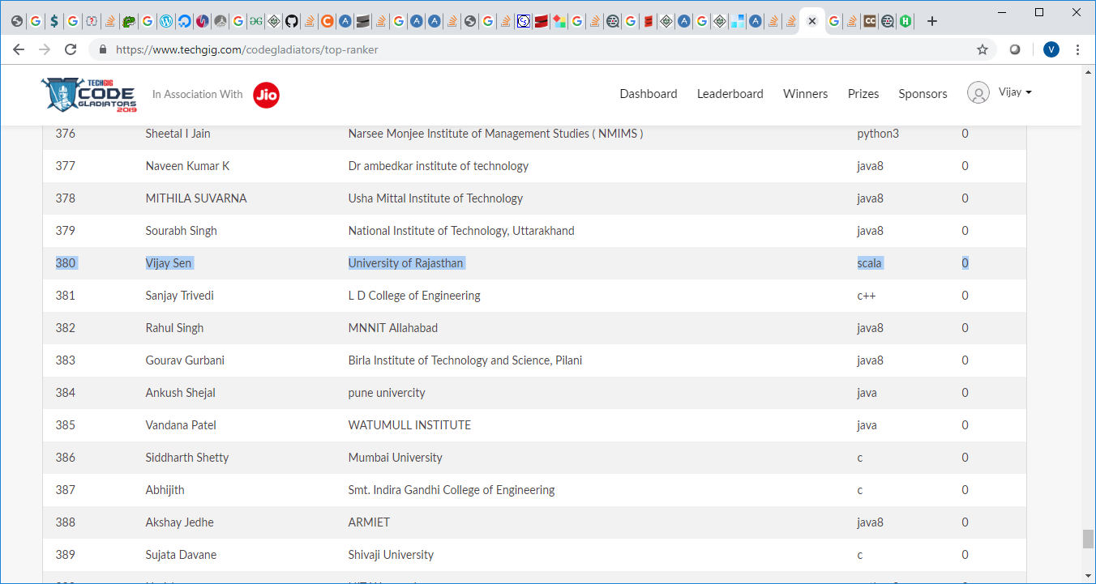

## ROADIES (100 Marks)

The last season of Roadies was very much criticised by the people as the contestants were dumb.Rannvijay got fed up with people showing only muscles and are without brain.

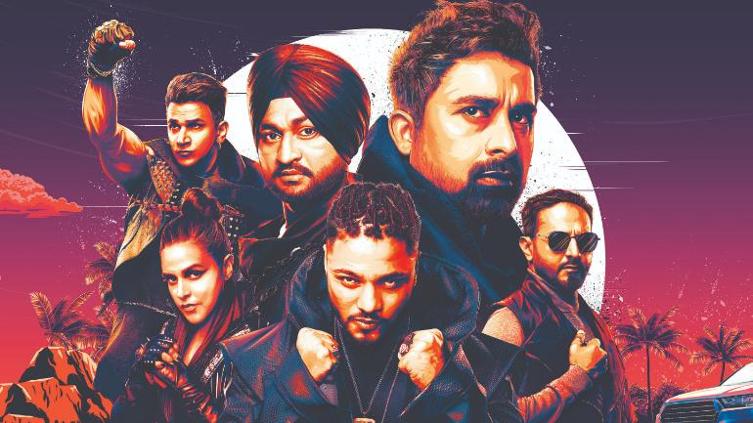

Rannvijay Singha wants some smart people in this season of Roadies. So, he has decided to give a task. The people who will successfully solve the task will be selected for the final round of Roadies. Rannvijay is a great fan of Mathematics and always want to score maximum.

He has an interesting task to be solved which will require observation and knowledge.

Rannvijay explains the task to you - "There are N boxes placed in a horizontal line infront of you with each box having a positive integer written on it. You have to tell me the maximum sum which can be formed by choosing the subset of boxes. Simple. But it is Roadies, so it can't be that simple. You have to tell me the maximum sum but the subset of boxes should not have any digit in common.

Let me give you an example, Suppose there are 5 boxes with positive integers as 14, 12, 23, 45, 39.

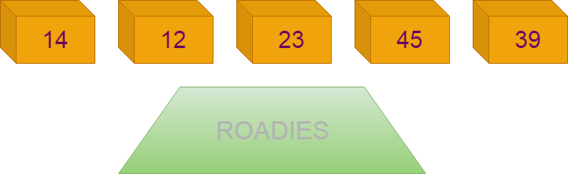

14 and 12 cannot be taken in the subset as 1 is common in both. Similarly {12, 23}, {23, 39}, {14, 45} cannot be included in the same subset.

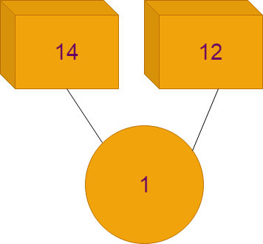

So the subset which forms the maximum sum is {12, 45, 39}. The maximum sum such formed is 96.

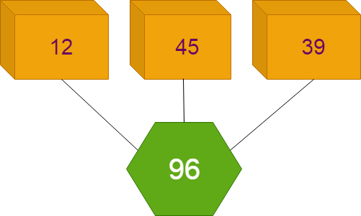

I hope everything is clear. So show your skills and meet me in the final round. Good Luck!."

##### Input Format

The first line of the input consists of the number of test cases, T.

The first line of input consists of the number of Boxes, N

The second line of each test case consists of N space separated boxes with positive integers on them.

##### Constraints

1<= T <=5

1 <= N <= 100

1 <= array elements <= 10^5

##### Output Format

Print the maximum sum which can be formed for each test case in a separate line.

##### Sample TestCase 1

###### Input

3  
4  
3 5 7 2  
5  
121 23 3 333 4  
7  
32 42 52 62 72 82 92

###### Output

17

458

92

###### Explanation

Test Case 1: {3, 5, 7, 2} = 17

Test Case 2: {121, 333, 4} = 458

Test Case 3: {92} = 92

**Time Limit(X):**

0.60 sec(s) for each input.

**Memory Limit:**

512 MB

**Source Limit:**

100 KB

**Allowed Languages:**

C, C++, C++11, C++14, C#, Java, Java 8, Kotlin, PHP, PHP 7, Python, Python 3, Perl, Ruby, Node Js, Scala, Clojure, Haskell, Lua, Erlang, Swift, VBnet, Js, Objc, Pascal, Go, F#, D, Groovy, Tcl, Ocaml, Smalltalk, Cobol, Racket, Bash, GNU Octave, Rust, Common LISP, R, Julia, Fortran, Ada, Prolog, Icon, Elixir, CoffeeScript, Brainfuck, Pypy, Lolcode, Nim, Picolisp, Pike, pypy3

## Elections (100 Marks)

Two national parties BJP and Congress are head to head in the election and are blaming each other as always. The Election has become interesting because of the importance of Regional parties. BJP is boasting on the work done during their tenure by the Government and how much they thought for the nation and people. On the other hand, Congress and other parties are calling it a hoax and urging people to vote for them. BJP star campaigners are just launching the missiles and making place amongst the people again. Congress is worried because of their track record and are breaking the boundaries to get to the people. The other Regional parties are also pulling out every trick in their book. The Election is taking ups and downs frequently.

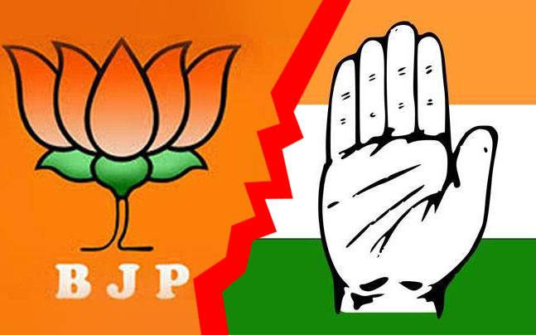

The voting is done in various phases and News channels are on the edge of their seats covering the areas where elections are to be held. Opinion polls are being conducted in the areas and public opinion is taken to predict the winner of the elections. People are also talking whether the Modi led Government will continue to rule or the Congress and other parties would be able to pull out some magic.

There are many political pandits and experts in the news industry which are covering the elections for a long time now. With their experience in the political field, they have come out with a theory which they claim can predict if the BJP government will come to power again or not.

The experts have formed a matrix in the form of **Phases** and **States**.

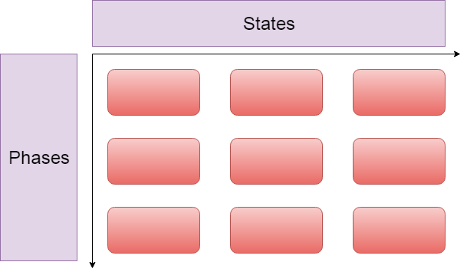

The experts have provided the number of wins required by BJP in different phases and states to form the government. According to theory, if it is possible to arrange the wins required by BJP in the form of experts matrix, then they will definitely form the government otherwise there will be a new government.

If BJP can form the government as per the theory, then the output would be **"YES"** indicating that people are happy with the government otherwise the output would be **"NO"** indicating that people are unhappy with the government.

**Note:** There are different seats in States which are to be voted in different phases. The number of phases and states is not restricted to the actual number of states and phases in the Indian Election.

##### Input Format

The first line consists of **T,** number of test cases.

The first line of each test case consists of **r** and **c**, number of phases and states respectively.

The second line of each test case consists of the number of wins **ri** required by BJP in the phases to win elections.

The third line of each test case consists of the number of wins **ci** required by BJP in the States to win the elections.

##### Constraints

1<=T<5

1<= r, c <=100000

0<= ri <=c

0<=ci <=r

##### Output Format

Print "**YES"** (without quotes) if BJP can form the government as per the experts theory otherwise print "**NO"** (without quotes).

##### Sample TestCase 1

###### Input

2  
3 2  
2 1 0   
1 2   
3 3  
3 2 1   
1 2 2

###### Output

YES

NO

###### Explanation

Test Case 1:

As per the theory, to form the government, BJP should win 2 seats in the first phase, 1 seat in second phase and 0 in last phase.

BJP also needs to follow the number of wins in states column wise. There should be a single win in the seats of first state and 2 wins in the seats of second state.

https://lh3.googleusercontent.com/fTUuXRzeWG9ZD2r0uG78dcEisNTHC4DADhQEyMvhp-hio56-G4LSTesH6zRdJeg6nejVW7xIlMsCU7IufoEj62k83XKwtSGkPbubLLIt74528oPTvoYeQ0rbvpAz2mL3pPOwrwo

It is possible for BJP to win the seats in this format and form the matrix as per the theory.The matrix can be successfully made thus BJP can form the government. Thus, the answer is **YES.**

Test Case 2:

It is not possible to create the matrix with respective wins by BJP in phases and states. Thus, the answer is **NO.**

**Time Limit(X):**

1.00 sec(s) for each input.

**Memory Limit:**

512 MB

**Source Limit:**

100 KB

**Allowed Languages:**

C, C++, C++11, C++14, C#, Java, Java 8, Kotlin, PHP, PHP 7, Python, Python 3, Perl, Ruby, Node Js, Scala, Clojure, Haskell, Lua, Erlang, Swift, VBnet, Js, Objc, Pascal, Go, F#, D, Groovy, Tcl, Ocaml, Smalltalk, Cobol, Racket, Bash, GNU Octave, Rust, Common LISP, R, Julia, Fortran, Ada, Prolog, Icon, Elixir, CoffeeScript, Brainfuck, Pypy, Lolcode, Nim, Picolisp, Pike, pypy3